Ethnographic Data of Tsumago

By Desideria Murti, 2018.
Supported under Sumitomo Research Grant 2016

A. Interview data

No | Code of Participants | Month/Year | Number and Function of Interviewees | Duration in min
1 | TS_LP_TX_YS | April, 2018 | 1 taxi driver | 30
2 | TS_LP_TX_SH | April, 2018 | 1 taxi driver | 35
3 | TS_LP_FO_RT | April, 2018 | 1 front office | 40
4 | TS_LP_FO_HG | April, 2018 | 1 front office | 40
5 | TS_LP_TO_RE | April, 2018 | 2 tourism officers | 40
6 | TS_LP_GU_TY | April, 2018 | 1 local guide | 30
7 | TS_LP_CO_HI | April, 2018 | 1 café owner | 45
8 | TS_LP_CO_TH | April, 2018 | 1 café owner | 45
9 | TS_LP_TR_YT | May, 2018 | 1 tourist | 30
10 | TS_LP_TR_FA | May, 2018 | 2 tourist | 30
11 | TS_LP_TR_PY | May, 2018 | 1 tourist | 30
12 | TS_LP_HS_RF | May, 2018 | 1 homestay owner | 45

B. Photographic Data

Figure 1. The Map of Tsumago in the Nagiso Station
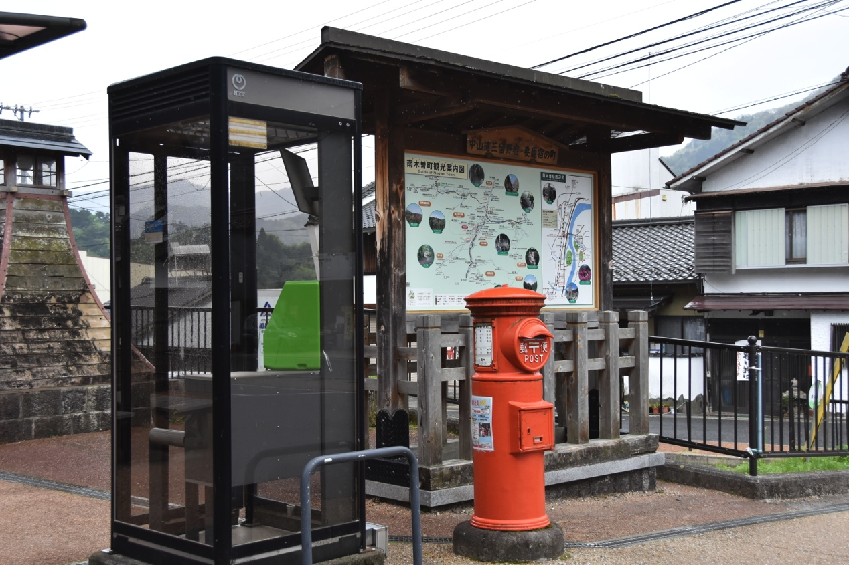
Source: Photo by Author, 2018

Figure 2. Street in the end street of Tsumago
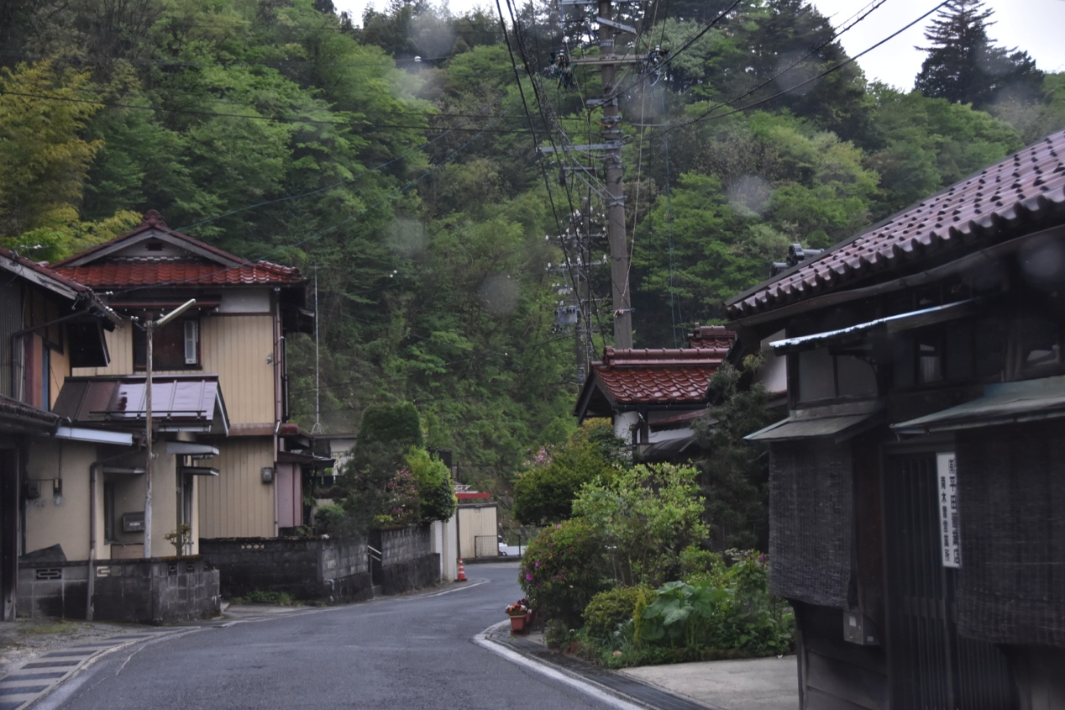
Source: Photo by Author, 2018

Figure 3. The mountain landscape view
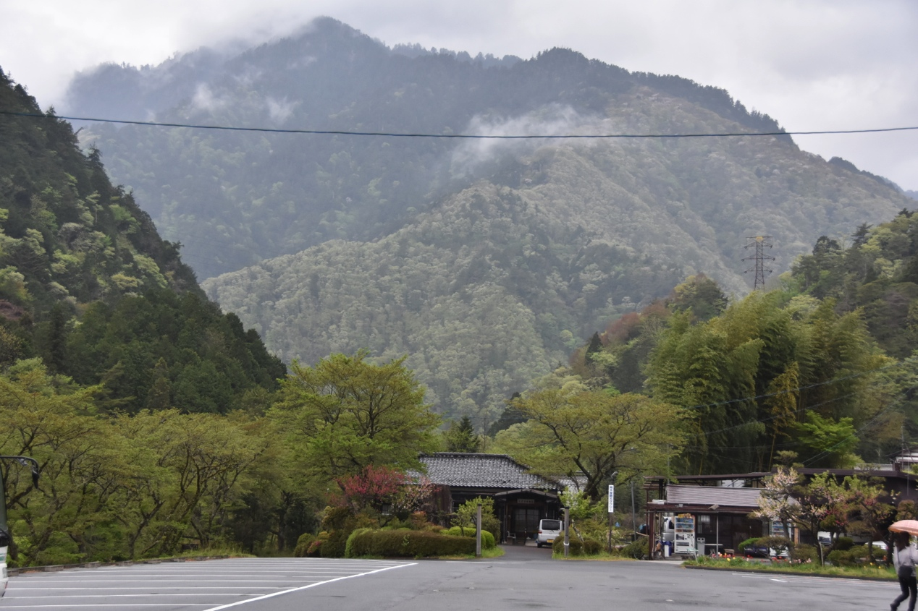
Source: Photo by Author, 2018

Figure 4. One of the entrance road to Tsumago Juku

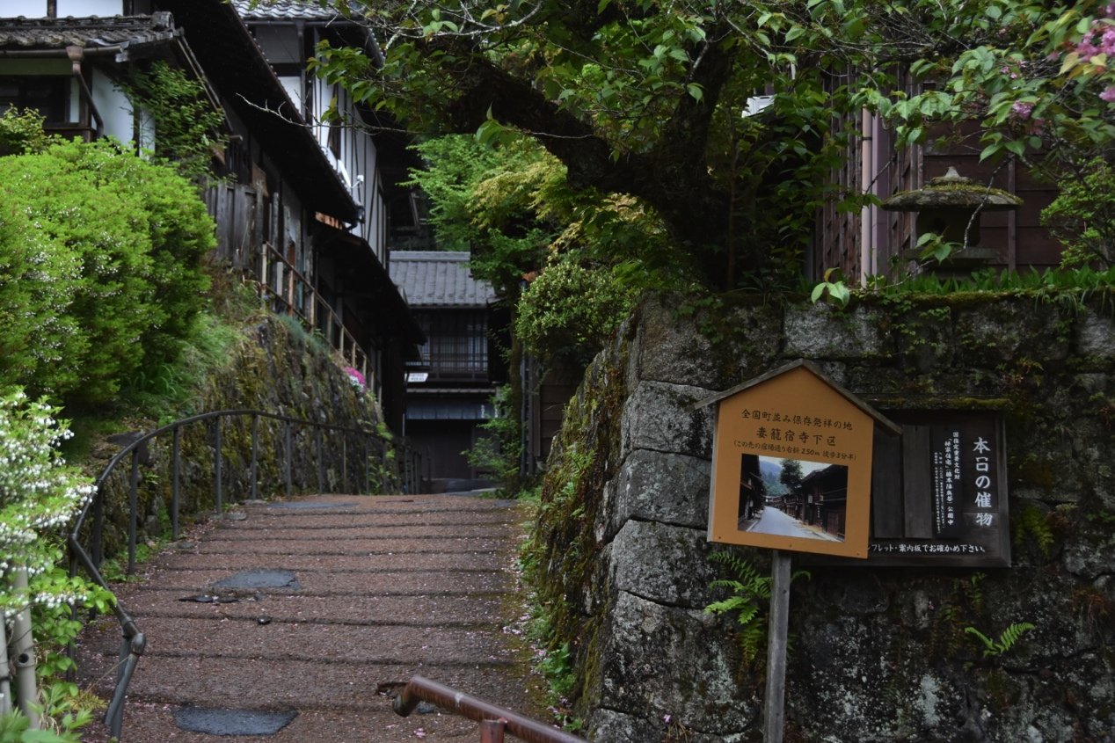
Source: Photo by Author, 2018

Figure 5. Streetscape in Tsumago
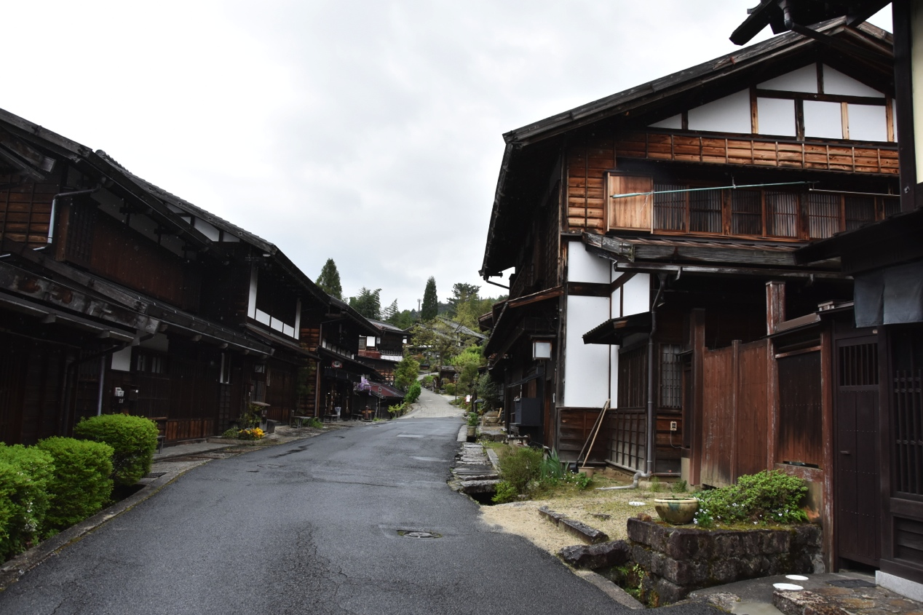
Source: Photo by Author, 2018

Figure 6. Streetscape in Tsumago
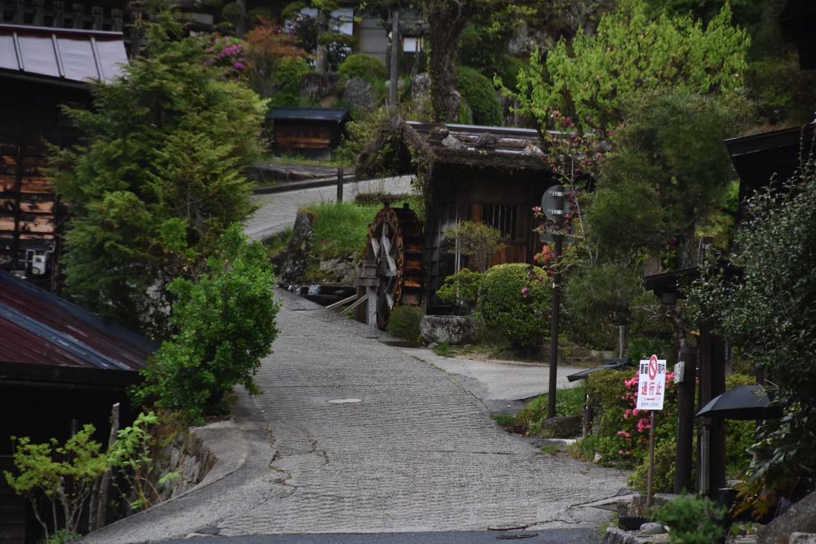
Source: Photo by Author, 2018

Figure 7. Streetscape in Tsumago
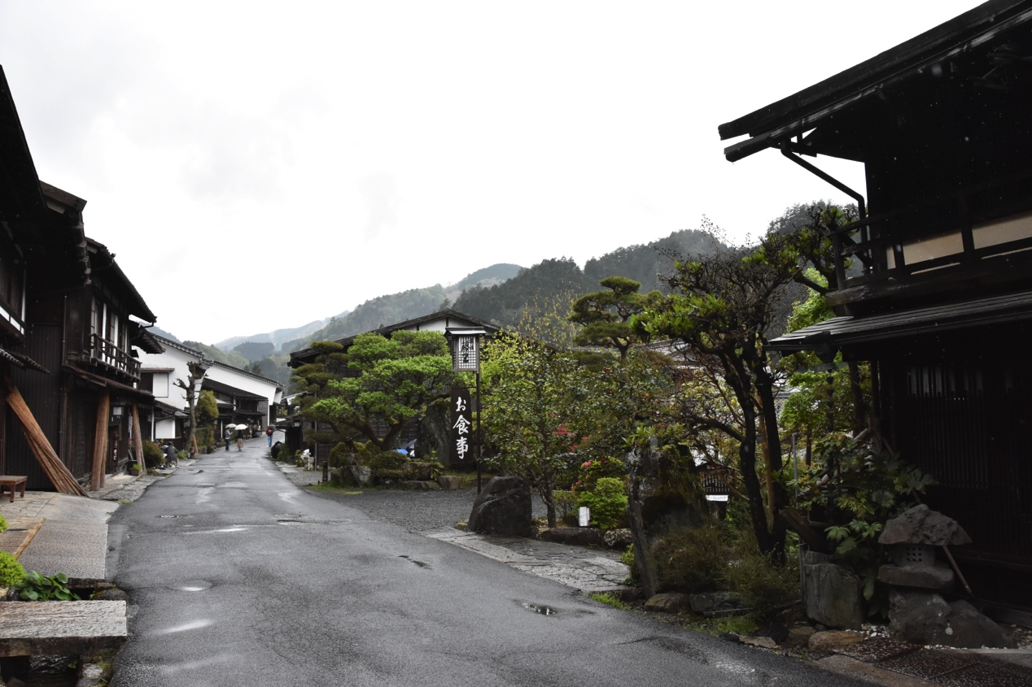
Source: Photo by Author, 2018

Figure 8. One of the local shop in Tsumago

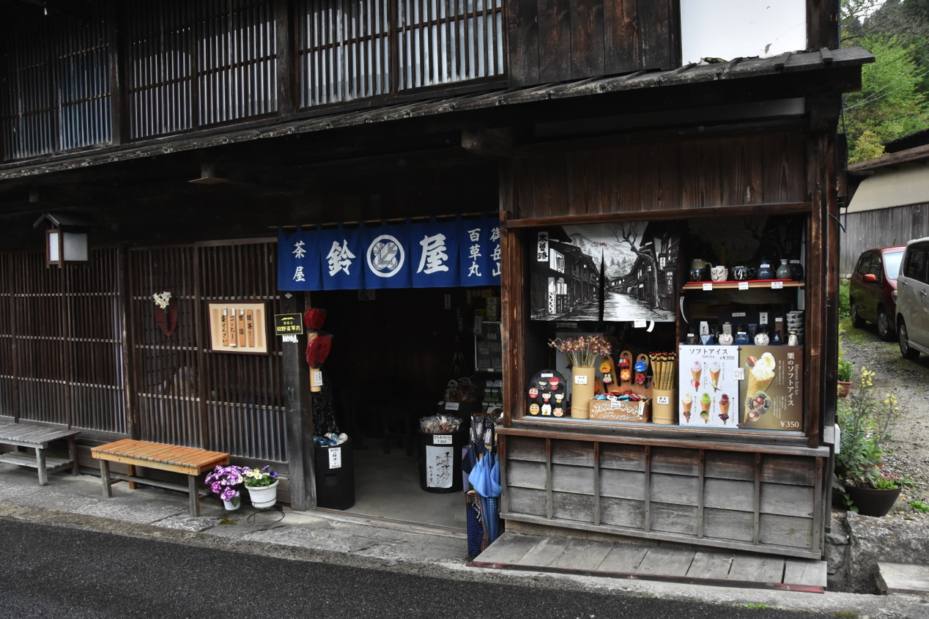
Source: Photo by Author, 2018

Figure 9, One of the homestay in Tsumago
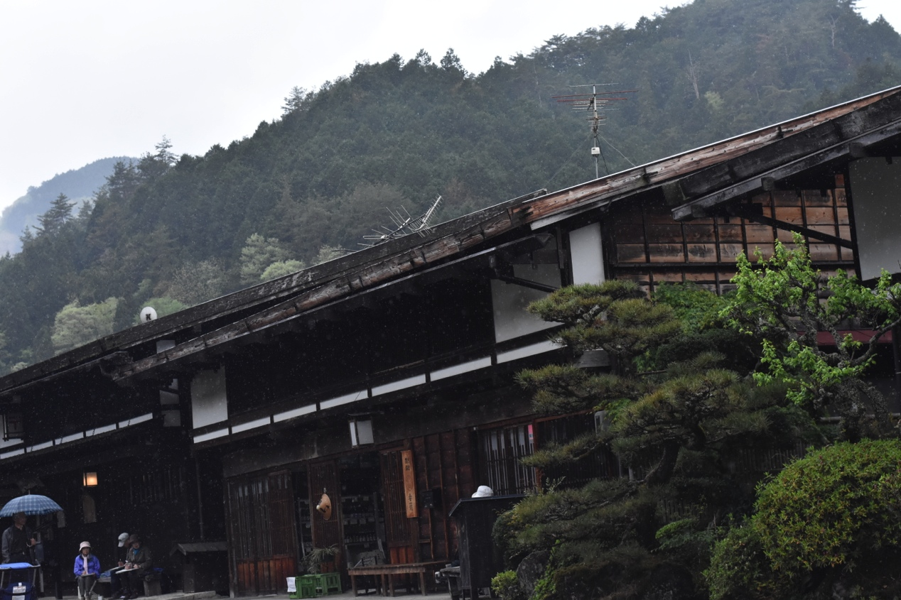
Source: Photo by Author, 2018

Figure 10. People pray in the shrine

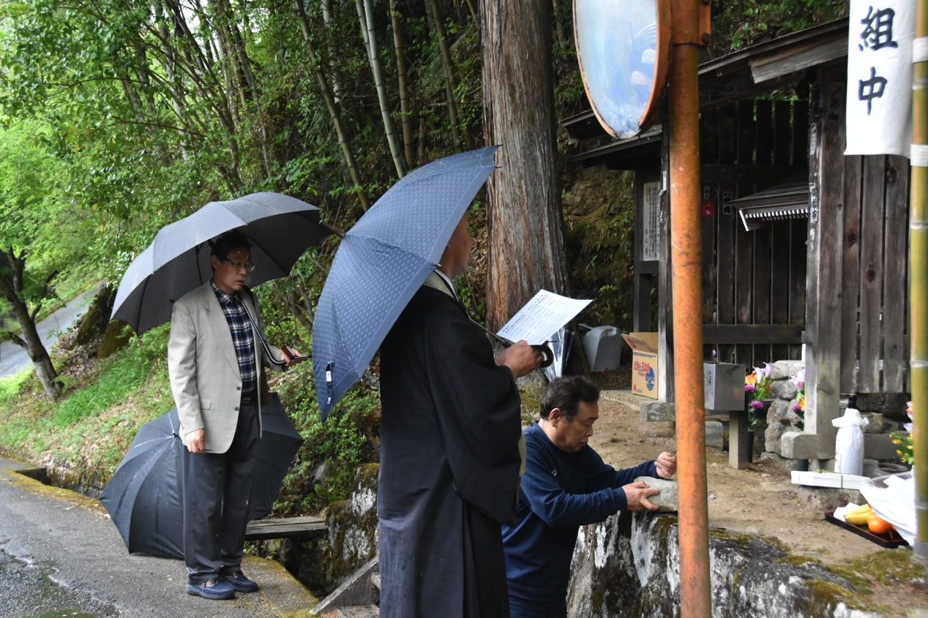
Source: Photo by Author, 2018
Figure 11. One of the decorated garden in Tsumago

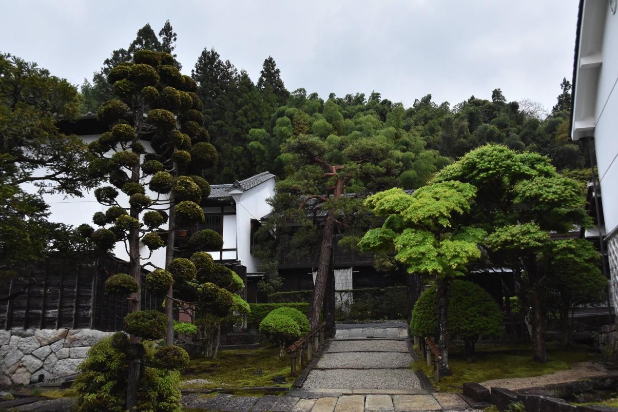
Source: Photo by Author, 2018

Figure 11. One of the renovated building in Tsumago

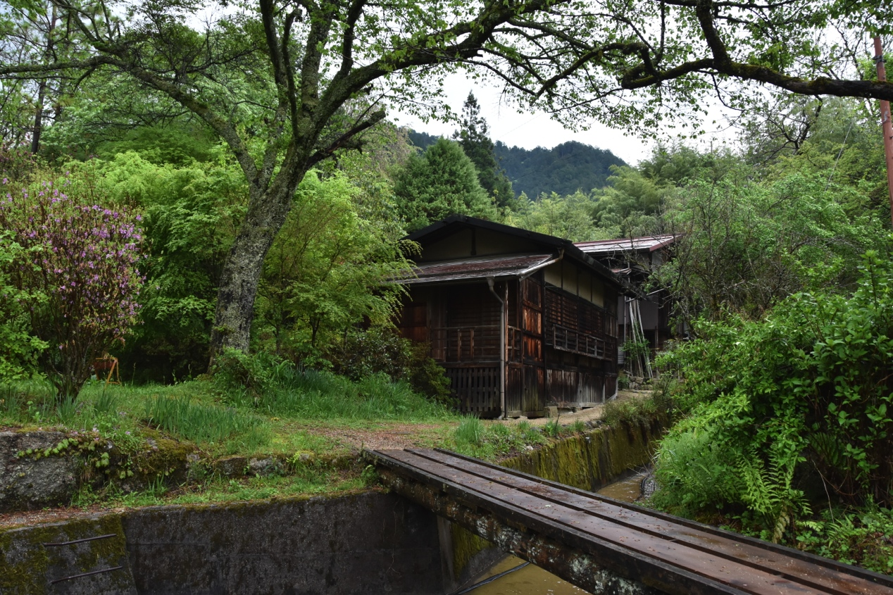
Source: Photo by Author, 2018

Figure 12. Explanation media in Tsumago

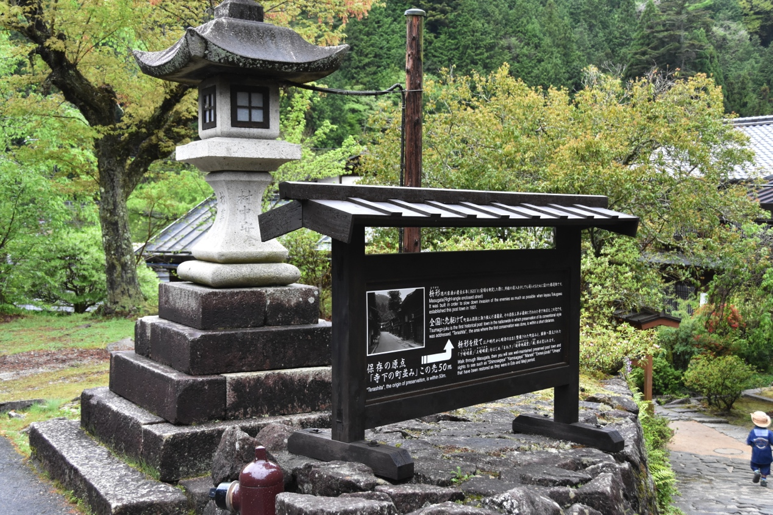
Source: Photo by Author, 2018

Figure. 13 Collections of photos, books, and documents in the Museum of Tsumago

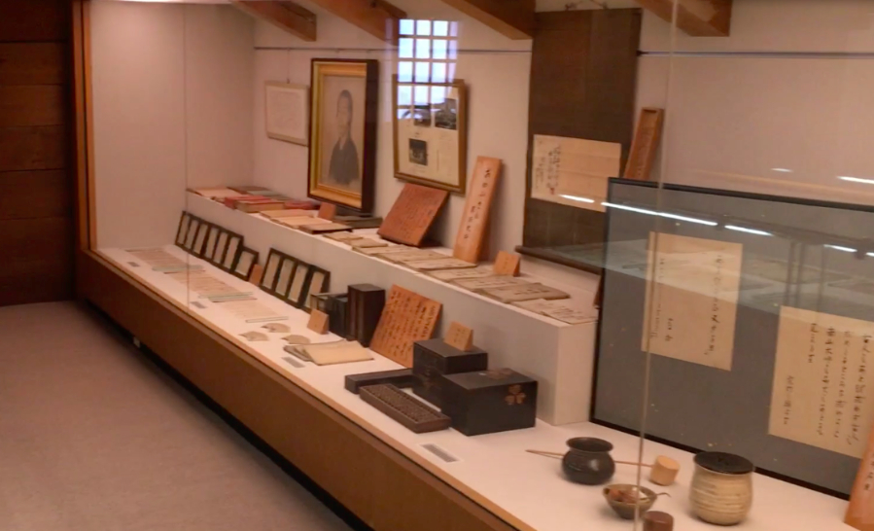

Source: Photo by Author, 2018

