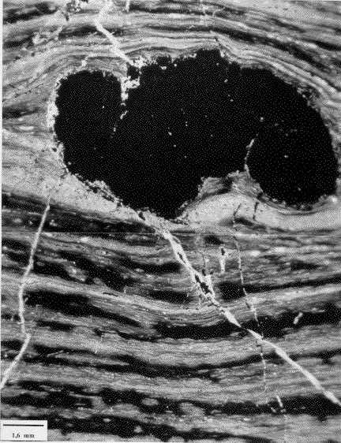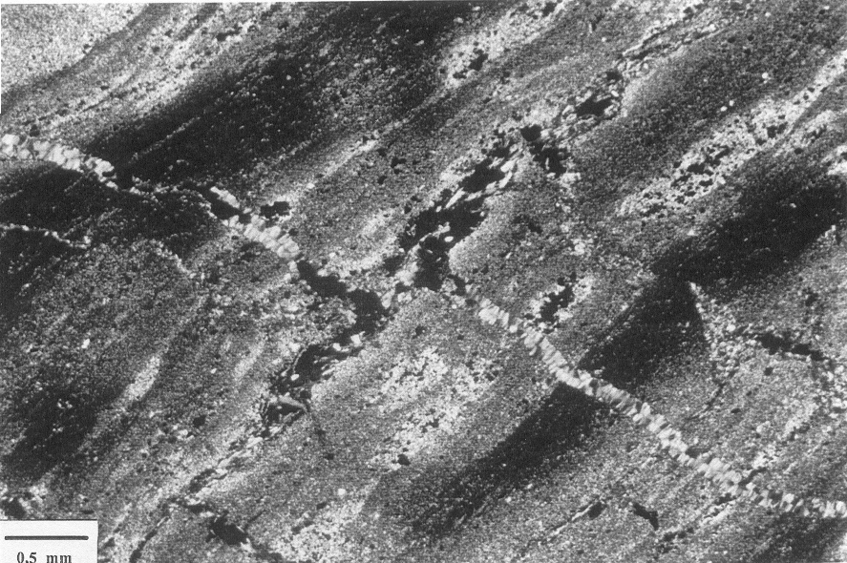

A

B
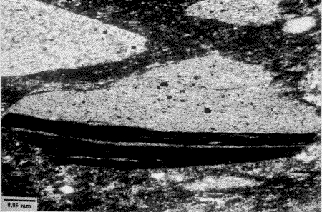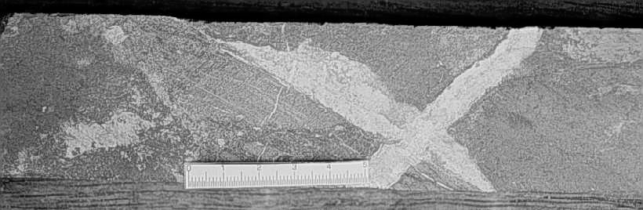

C

D

F
cpy
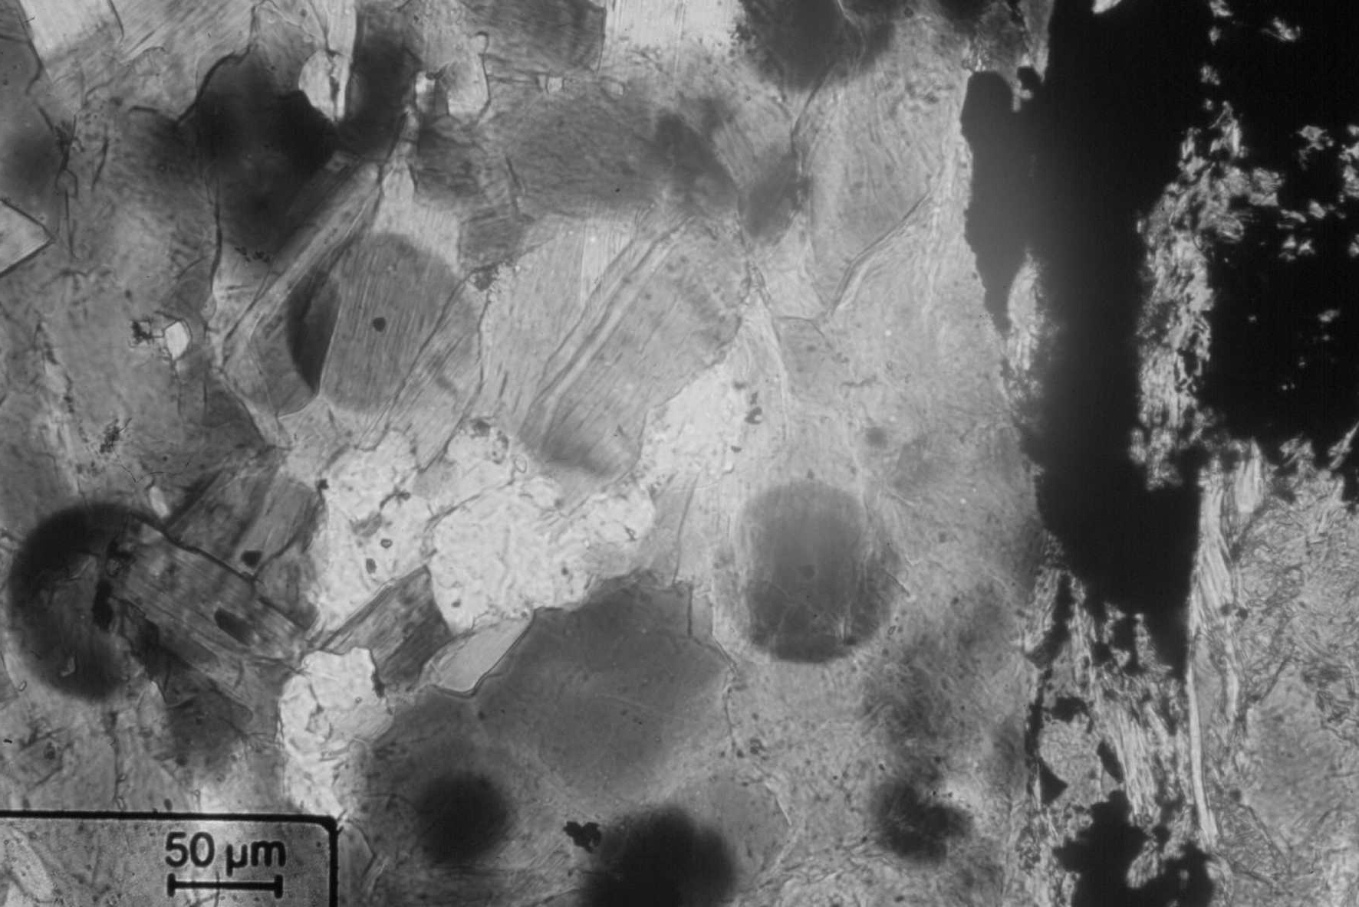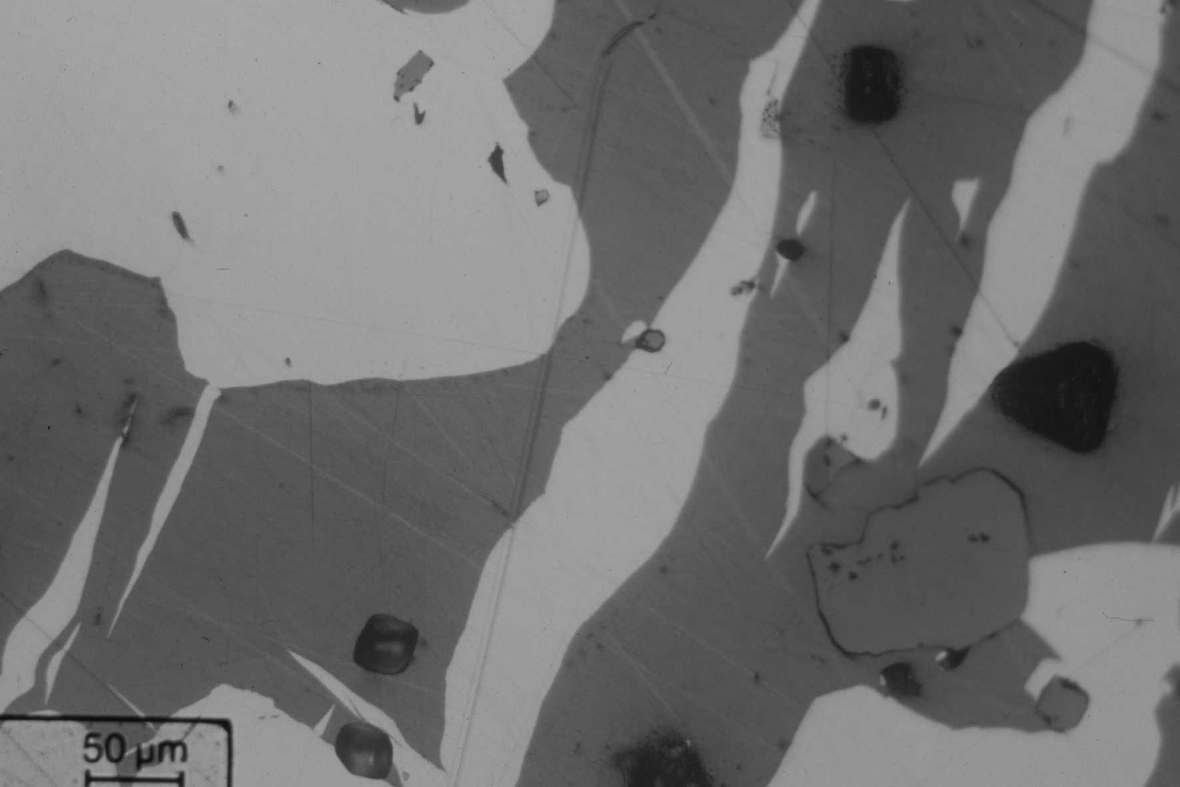

E
cpy
bn
mt
bi
Fig. 4. A. Photomicrograph of a chalcopyrite (cpy) nodule that bents the sedimentary bedding and is connected to discordant veins containing chalcopyrite. Plane-polarized light. 384/141.50m. B. Photomicrograph of a set of discordant and concordant chlorite + chalcopyrite veins crosscutting the sedimentary bedding. Plane-polarized light. 384/141.20m. C. Photomicrograph of a mineralized Fe-chlorite breccia with a fragment of laminated sedimentary rock from the hangingwall welded by a chlorite ± magnetite ± chalcopyrite matrix. Plane-polarized light. 353/168.70m. D. Magnetite breccia with abundant chalcopyrite (cpy) being crosscut by carbonate veins. BHMAG-003/407.25m. E. Photomicrograph of the matrix of a magnetite breccia with abundant biotite (bi), showing pleochroic halos due to uraninite inclusions. Plane-polarized light. BHMAG-003/407.25m. F: Photomicrograph of the matrix of a magnetite breccia showing the equilibrium between chalcopyrite (cpy), bornite (bn) and magnetite (mt). Reflected light. BHMAG-001/476.00m.

